# Module 6 Activity 1

# Brandon Trinkle

# IFT 458: Middleware Prog & Database Sec

# Professor: Dinesh Sthapit

# Mar 22, 2025

# Module 6 Activity 1

1. *Screenshots Of app.js showing the chained middleware implementation.*

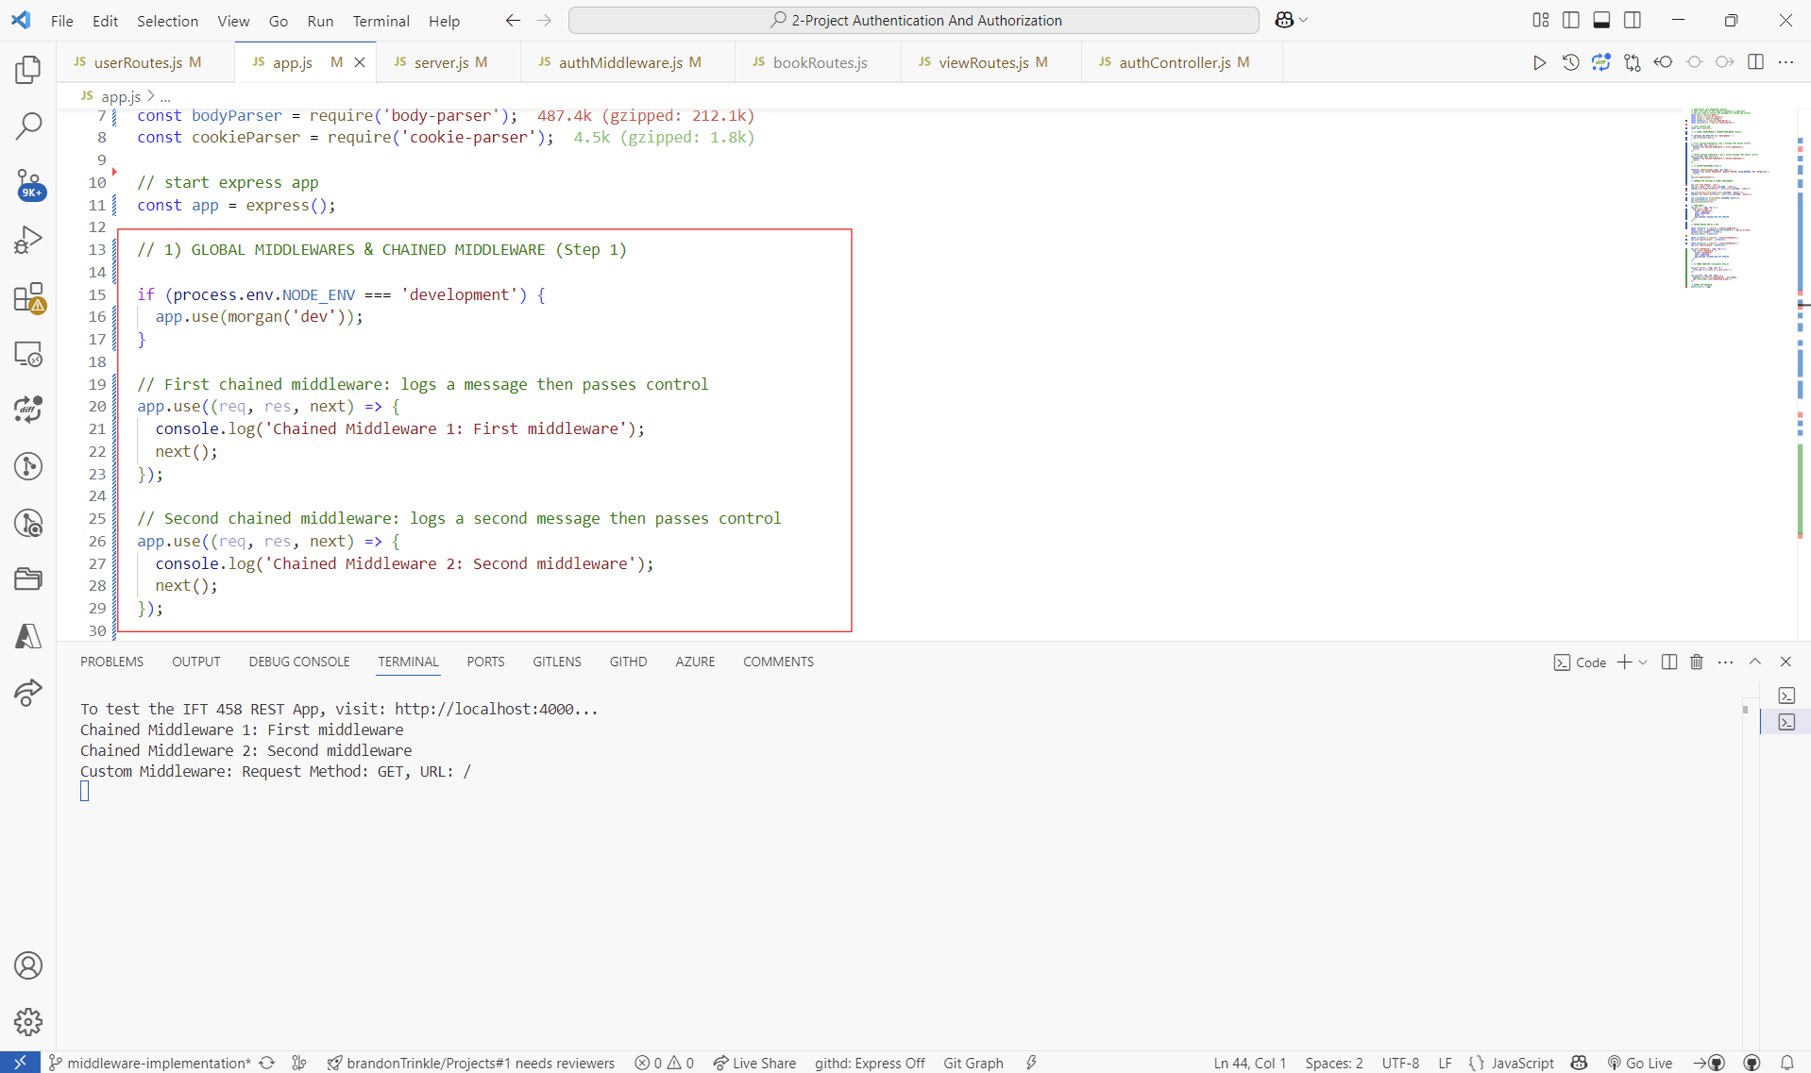

1. *Screenshot 2: Of the custom middleware code in app.js.*

1. *Screenshot 3: Of the error handling middleware in app.js.*

1. *Screenshot 4: Of the /error route and the error response in the browser or terminal.*

